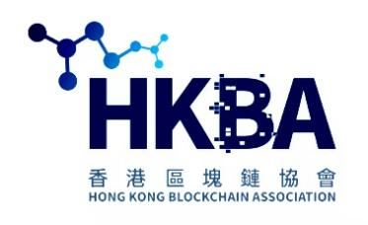
香港區塊鏈協會 HKBA 入會申請表
Hong Kong Blockchain Association HKBA
Membership Application Form 2023d
請在方格內打上√ Please check √ the box. 請用正楷填寫以下資料 Please complete this application form.
入會申請資料 Membership Application Information ( Also Available Online at HKBA.club )
姓名 中文Chinese Name |  | 性別 Gender: □男Male, □女Female, □Other __
姓名 英文 English Name
企業機構名 Organization Name |  | 職位 Job Title
電話 Tel. Office/Home |  | SNS WeChat  FB IG Twitter
手機 Mobile / WhatsApp |  | 郵箱 Email
通訊位址 Address Work/Home
個人主要學歷和經歷 Personal Description:

Pls List Your Blockchain / NFT Skills: □
企業機構 簡介 Company/Organization Description:
What do you hope to achieve by joining HKBA: □ Education/ Training, □ Events / Networking , □ Job Opportunities , □ Others, pls list ____

*關於您的資料與個人隱私: 為確保會員資料詳盡、準確、及時，您所提供的資料日後如果有所變更，請儘早通知本會在有關記錄上作相應的修訂。您如果想核實本會記錄中的資料，可向本會索取最新記錄副本。 會員為加入本會而提供的資料，只可供本會用作與會籍有關的用途，例如印製會員名錄、印發會員證書、發送通告和出版刊物、研究調查、舉行選舉會議或其他直接有關的活動。您如果在這些資料的使用上有任何其他安排，或者不希望接收某些資訊，請Email/書面通知本會。
*Personal Data Privacy Policy: In order to ensure that the information supplied by members is complete, accurate and updated, we would appreciate it if members would inform the Association about any changes as soon as possible. If you wish to verify your own information, you can also ask for a copy of the latest record. The membership data can be used by the Association for membership related purposes such as printing of the Members Directory, issuing membership cards, sending out circulars and publications, holding election meetings, or any other directly related activities. If you wish to make alternative arrangements or not to receive certain information, please inform us in writing/email.
HKBA Membership Application Acceptance Statement:
本人_______________________________________ 茲申請加入香港區塊鏈協會 HKBA。
本人願遵守商會章程，確認上述資料完整無誤，可供香港區塊鏈協會HKBA用作與會籍有關的用途。

I, ________________________________________, hereby apply for membership in the Hong Kong Blockchain Association HKBA and agree to abide by the rules and regulations of the HKBA. I further confirm that information furnished above is complete and accurate and can be used by the Association for membership related purpose.

申請人簽名 Membership Application Signature: _____________________ 日期 Date:_____________
申請會籍Apply Member Type: □ 企業機構會員 Enterprise Member ; □ 個人會員 Individual Member ; □ 學生會員Student Member

請填妥本表格回傳至 香港區塊鏈協會。 Please complete this form and send back to Hong Kong Blockchain Association.
Membership Fee Payment/Donation, Pay To: HKBA Limited , or, Dena Group Limited ( Trust & Company Service Provider TCSP License), or BTC/ETH/USDT

電郵 Email: info@HKBA.club ; Web: www.HKBA.club ; Facebook.com/HongKongBA ; Linkedin.com/company/HongKongBlockchainAssociation
HKBA: 香港 九龍 尖沙咀 麼地道68號 帝國中心 Empire Centre, Office 801B ; Empire Centre 801B, 68 Mody Road, TsimShaTsui East, Kowloon, Hong Kong.
HKBA SZ Dena Law Office: 深圳 福田 金田路3037號 金中環商務大廈4205室 ; Room 4205, Jinzhonghuan Business Building, Futian District, Shenzhen, China.

此欄由協會工作人員填寫 （For HKBA Staff Use Only）
會員編號 Membership No.: Referral Code : Approval Code:
備註 Remarks:

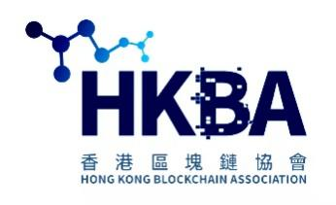
香港區塊鏈協會 HKBA 入會申請表
Hong Kong Blockchain Association HKBA
Membership Application Form 2022d
.
HKBA Membership Application - Additional Documents
Please Include Your: Personal Bio, CV, Business Card, References, Social Links.
We may list your information in the HKBA Membership Directory with your approval. Please attach any additional information documents as needed.

香港區塊鏈協會 Hong Kong Blockchain Association HKBA.club
香港區塊鏈協會HKBA 是一個開放、自主、平等的去中心化組織 Decentralized Organization DAO。 通過學習、交流及推廣區塊鏈技術應用及 NFT Metaverse元宇宙教育，HKBA致力於成為大中華及元宇宙世界的銜接平台, 並將香港打造成新時代的金融科技元宇宙中心。

會籍會員優惠 HKBA Membership Benefits
香港區塊鏈協會HKBA是香港最國際化的本地區塊鏈協會,亦是最本地化的國際商會。我們的會員網絡包羅香港互聯網企業、區塊鏈金融 、科技企業、金融證券企業、上市公司、跨國集團，以及眾多蓬勃發展的中小企業和初創公司，從事業務包括金融科技FinTech、Blockchain、雲計算/雲數據中心 Cloud Data Center、NFT、Metaverse元宇宙教育、網絡安全Security、科技、電訊、 NFT Art及法律Legal 專業服務 等等。
請即加入本會，開拓人脈，反映意見！ HKBA雄厚和具廣泛代表性的會員網絡，主導我們成為金融科技界之聲；我們助您擴闊商業圈、緊貼市場脈搏和開展業務。只需一個企業會籍，貴公司的所有全職員工都可以全面地享用本會的各項服務和優惠。

HKBA 會籍專享優惠
參與HKBA的會員專享重點活動, 擴展業務和聯繫;
HKBA元宇宙教育學院 Edi.College 課程,
HKBA專業進修證書及文憑,提升自我潛能「HKBA專業證書及文憑」;
出席各式各樣的 Blockchain NFT Metaverse Education 知識型活動和培訓坊,
元宇宙教育學院 Online Training, Certificates, Diploma 專業證書及文憑; 緊貼市場最新發展和更新技能;
HKBA FinTech & Virtual Assets Management 政策意見,締造更佳的營商環境, 及其他商業推廣服務優惠。 請按此查閱HKBA會員服務詳情
其他優惠
以優惠價參加HKBA每年舉辦 項活動。
免費列入HKBA網站內的 會員名冊。
免費於「 會員優惠計劃」刊登宣傳單張。
免費獲贈《HKBA Blockchain News 月刊》。
專享其他會員提供的商品及服務優惠。
於HKBA網站刊登廣告可獲特別折扣優惠。
可於《HKBA Blockchain News 月刊》及本會網站刊載會員專訪及分享資訊。
擔任HKBA活動演講嘉賓。
申請加入政策、行業及地區事務委員會及聯誼會。
其他自訂商業服務。

HKBA 會籍會費 Membership Fees:
企業機構會員 HKBA-Corporate-Member HKD$20,000
SME企業機構會員 HKBA-Corporate-Member HKD$10,000
資深會員 HKBA-Fellow HKD$5000
會員 HKBA-Member HKD$1500
學生/附屬會員 HKBA-Affiliate HKD$100

Hong Kong Blockchain Association 香港區塊鏈協會 HKBA Membership Fee ( Edi.College 元宇宙教育學院 Tuition) Payment Methods:
HKBA Limited. Standard Chartered Bank account: 41500548577 ; 香港渣打銀行 SWIFT Code: SCBLHKHHXXX ; www.StandardChartered.com.hk
We accept the following currencies and payment methods: HKD$, USD$, CNY/RMB, bank wire, cheque, Faster Payment System ( FPS 轉數快), WeChat, AliPay payments.
HKBA in partnership with HKD.com HKOTC.co to accept HKD HDAO payment services for HKBA Membership and Online Education Payments:
HKD.com 香港九龍彌敦道528號 Onward Building G/F, 528 Nathan Road, YauMaTei, Kowloon, Hong Kong. ( Sam.Tsang@HKD.com +852-55287627 )
HKBA: 香港 九龍 尖沙咀 麼地道68號 帝國中心 Empire Centre, Office 801B ; Empire Centre 801B, 68 Mody Road, TsimShaTsui East, Kowloon, Hong Kong.

HKBA Membership Application WhatsApp: +852-90971709 / 61820903 ; +852-55094404 PhillipWong HKBA Vice Chairman;
HKBA Meta Education WeChat ID: TT62500023;
HKBA Membership Email: info@HKBA.club , HongKongBlock@gmail.com , HKBA@Pacificnet.com

HKBA & Edi.College web links:
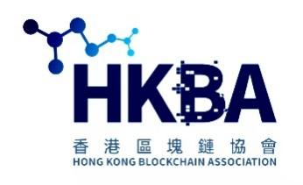
www.HKBA.club
https://Link1.in/HKBA
https://Twitter.com/TonyTongHKBA
https://Facebook.com/HongKongBA
https://Linkedin.com/company/hongkongblockchainassociation
HKBA.club Youtube Video Channel:
https://www.youtube.com/channel/UCxdIHJTUX_rZSm-X9vDxiTg

www.Edi.College
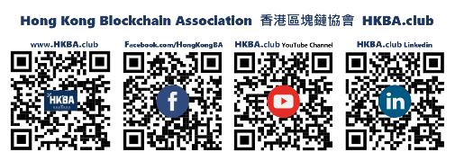
Facebook.com/EducationCollege
Twitter.com/EdiCollege
https://Link1.in/EducationCollege

